

Join us for a special one-night event featuring renown Psychic Medium Cathy Ripley Greene. Seating is limited, so reserve your spot today!

Sunday, October 25, 2026
6:30pm – 8:30pm
Norwood VFW
Cost: $ 60.00pp
After October 1^{st $}70.00pp (if seats are available)
Cash Bar – Bring your own snacks & an open mind

Venmo @citizensforabetternorwood or scan the QR code below to secure your tickets. Please state your name and number of tickets you wish to purchase.
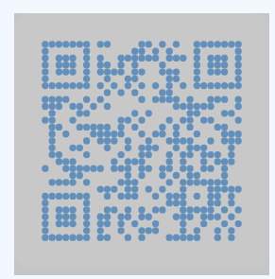

Proudly Sponsored by:
Citizens For A Better Norwood

